ENGINE & TRANSMISSION DEPARTMENT

**MAXIMUM VELOCITY**

RPMw = RPMe / ( Ip * Is )

[ RPMw = Wheel rpm RPMw =9500/(2.66*3)

RPMe = Maximum engine rpm = 9500 =1190

Ip = 2.66

Is = 3]

Vmax = R * RPMw * 0.10472 Vmax=0.25*1190*0.10472

[ Vmax = Maximum velocity **Vmax = 112.14 km/h**

R= Wheel radius = 0.25 m]

**TRACTIVE EFFORT**

**& DRIVE WHEEL MOTOR TORQUE**

TTE = RR+GR+AD

[ TTE=Total tractive effort

RR= Rolling resistance

GR= Force necessary to climb a grade

AD= Aerodynamic drag]

RR= GVW * Crr*g

[ GVW= Gross vehicle weight =300 kg RR=300*0.017*9.81

Crr = Surface friction = 0.017**] RR = 50.031 N**

GR = GVW * sinA *9.81 GR=300*0.173*9.81

[ A= Grade angle = 10°] **GR = 509.139 N**

AD = 0.5 * p * Cd * A * V^2

[ p= Density of air = 1.225 kg/m^3

Cd = Coefficient of drag = 0.9

A = Frontal area = 0.65h m^2 AD=0.5*1.225*0.9*0.65*31.15*31.15

V = Maximum velocity = 31.15 m/s] **AD = 347.9 N**

So, TTE=50.031+509.139+347.9

**TTE = 907.07 N**

Tw = TTE * R * Rf

[Tw = Drive wheel motor torque

R =Wheel radius = 0.25 m Tw=907.07*.25*1.12

Rf = Resistance factor = 1.12] **Tw = 253.98N-m**

**Gear Ratio=Tw/Te GR=253.98/35**

**Te-max. torque by engine GR=7.2:1[7:1]**

**ACCELERATION**

a = (550*g*HP)/(v*GVW)

[ a = Acceleration

g = Acceleration due to gravity = 32.2 ft/s^2

HP = 43hp

v = Max velocity = 102.198 ft/sGVW = 661.387 lb]

a=(550*32.2*43)/(102.198*661.387)

a = 11.26 ft/s^2 (or) **a = 3.43 m/s^2**

**MASS FLOW RATE**

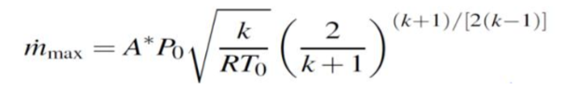

[ M = Mass flow rate

A = Area of restrictor throat = 3.14 * 10^-4

P = Pressure = 101325 Pa

K = Specific heat ratio = 1.4

T = Total temperature = 303 K

R = Ideal gas constant = 286 j/kg-K]

**M = 72 g/s**

**GRADEABILITY**

Fz=

[ Fz = Max Tractive force

Te= Max engine torque= 35Nm

η= Overall efficiency of drive train=0.9

ip=Primary gear ratio=2.66

is=secondary gear ratio=3

U=circumference of tyre=1.59m]

**Fz=992.83 N**

P= $[ \frac{Ft}{9.81×GVW}$-fr].100

[ P = Gradeability %

GVW=360 Kg,

fr=coefficient of rolling resistance = 0.007]

**P=27.41%**

**Distance travelled on uphill and downhill Gradient:-**

**C = l** . $\sqrt{l^{2}+{(p/100)}^{2}}$

[ c = Distance travelled on gradiance

l=Horizontal length in m = 100]

**C=103.68m**

**Angle of Uphill and Downhill Gradient:-**

tanα= $\frac{P}{100}$ = 0.2741

[ α = Gradeability angle]

α= 15.32°

CHAIN CALCULATION

k= $\frac{T1+T2}{2}$ + $\frac{2x}{p}$ +( $\frac{T1-T2}{2x})²$ $\frac{p}{x}$

*

[ k = no. of chain links

T1= Teeth on the differential sprocket = 45

T2= Teeth on the gearbox sprocket = 15

X = Center distance between the two sprocket = 10 in

P = Pitch of the chain = 0.625 in] k = 64

L=k*p

[ L = Length of chain ] L = 102cm

X= $\frac{p}{4}$ [k- $\frac{T1+T2}{2}$ + $\sqrt{{\left(k-\frac{T1+T2}{2}\right)}^{2}-8(\frac{T2-T1}{2*π}})²$]

[ x = Center distance between two sprocket

T1= Teeth on the differential sprocket = 45

T2= Teeth on the gearbox sprocket = 15

X = Center distance between the two sprocket = 25.4 cm

P = Pitch of the chain = 1.6 cm ] x = 25.4 cm

W= $\frac{Rated power }{Pitch line velocity}$

[ W= Load on the chain

Rated power – 43 HP

Pitch line velocity(V) - $π\frac{DN}{60}$

D - diameter of a sprocket = 0.08m

N - ­speed of rotataion of sprocket in RPM = 9500

V = 39.77 m/s] W = 821.724 N

F= $\frac{Wb}{W}$

[ F= Factor of safety for the chain

Wb = breaking strength of the chain

W=load on the chain

Wb = 106* p ^2=271.36 N

VENTURI

p = pitch of the chain ] F = 0.33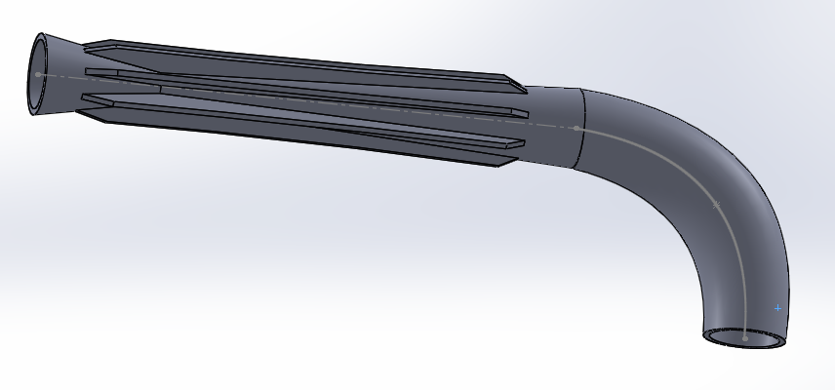

Engine and Transmission | December 3, 2016

DESIGN AND REQUIREMENTS

The basic requirement is that charge should flow through the restrictor of 20mm dia, so we have opted venturi design for maximum mass flow rate. In this venturi we have a converging and a diverging part which decreases the pressure and diverging part to gain the pressure. We have used plenum which acts like an air reservoir.

DIMENSIONS

Restrictor diameter - 20mm (19.6- tolerance 0.4mm)

Converged part length – 100 mm

Diffuser length – 350mm

Diffuser angle – 2.4 degrees

Air inlet velocity – 13 m/sec

VELOCITY ANALYSIS

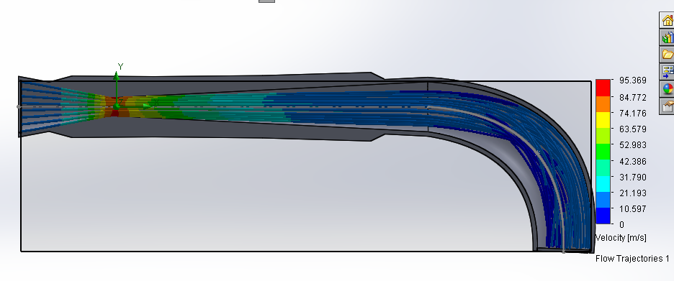

PRESSURE ANALYSIS

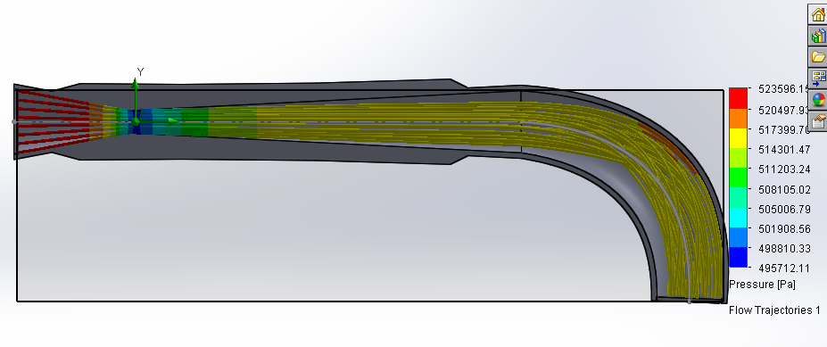

TEMPERATURE ANALYSIS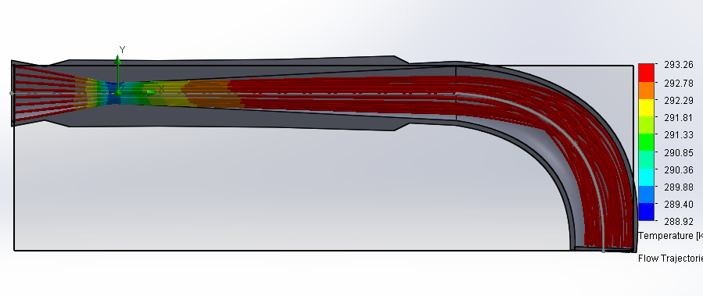

TURBULENCE ANALYSIS

TURBULENCE INTENSITY

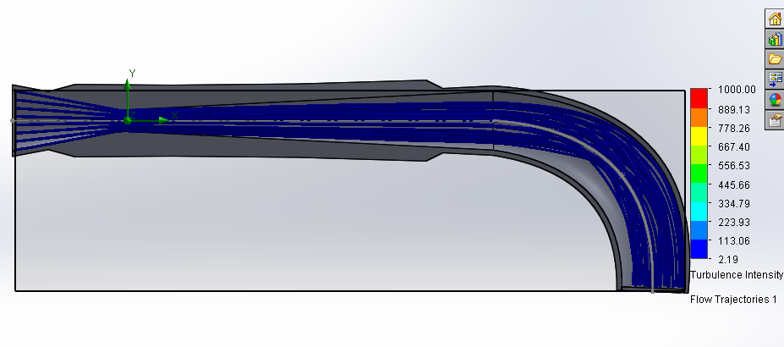

TURBULENECE TIME